These are requirements for processing reimbursements to Kuali accounts.

KFS reports must contain the following information:

KFS #

KFS Account name

Person’s name responsible for the account

Object Code

Object Code description

Posted date

Edoc #

Expense-item must be listed as final or actual expense NOT enroute

Below is the Kauli payroll report set up that is required for payroll reimbursements. This payroll report is sorted by employee, and there is a screenshot of where it would run it from and the correct sort.

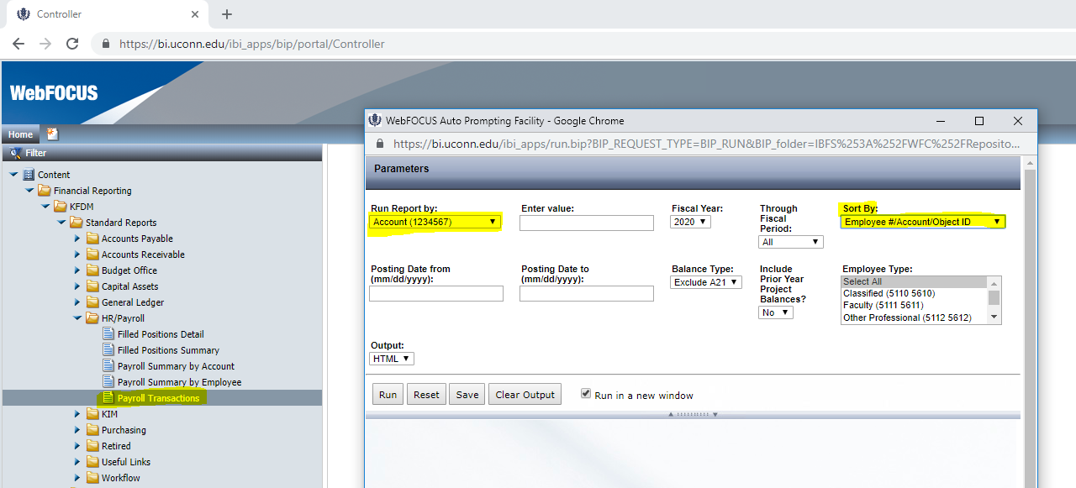

All RFD’s must have the following information:

A separated line for each type of object code –

* salary and fringe should be combined on one line but must have **a separate line for each employee** -listing employee name-with total amount and the date range of pay periods using posted date and the employee ID.
* One line expenses -must list edoc # and expense date.
* If the object code has several lines the expenses can be combined, listing the date range with the total amount-no edoc numbers need to be entered on the RFD.
* all travel can be combined on one line with date range of the expenses-no edoc numbers need to be entered on RFD.
* all supplies can be combined on one line with date range of expense-no edoc numbers need to be entered on the RFD.
* Awards, Fellowships and Scholarships must have **a separate line for each student** with semester noted and student ID ex: Smith,John Fall 2020